Industrial visit Tasty Bakery 09. 04. 2021
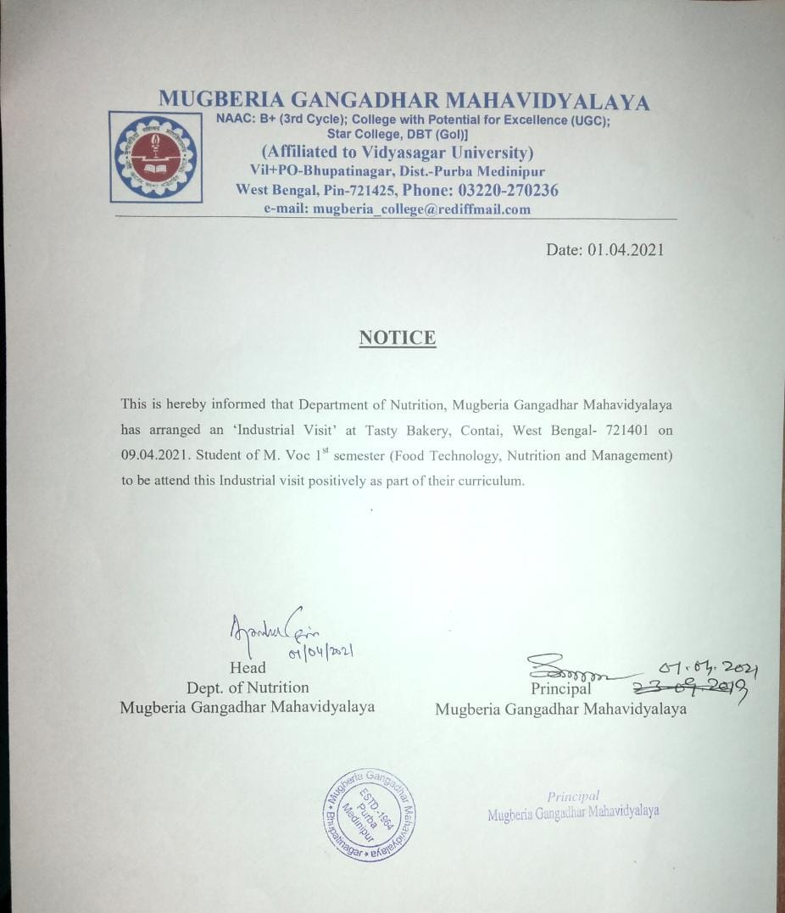
REPORT:
Department of Food processing organized a one day Industrial visit at Tasty Bakery, contain, Purba Medinipur, on 9th ^{April} 2021. Total M.Voc 1ST Semester 33 students (male-10 and female-23) with 5 faculty members (Male: 03 and Female: 02) participated in this visit. Industrial visits provide the students with an opportunity to learn practically through interaction, working methods and employment practices. It gives the students an exposure to current work practices as opposed to theoretical knowledge being taught at their college classrooms. The students are very much interested and motivated by observing the food industry. They requested our department to organize that type of industry visit in every year.

PHOTOS:
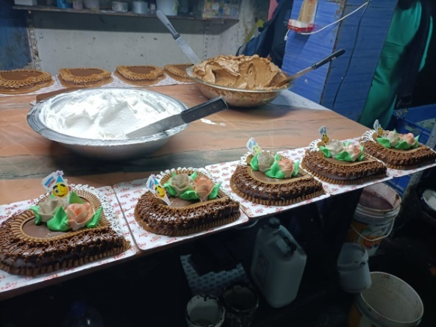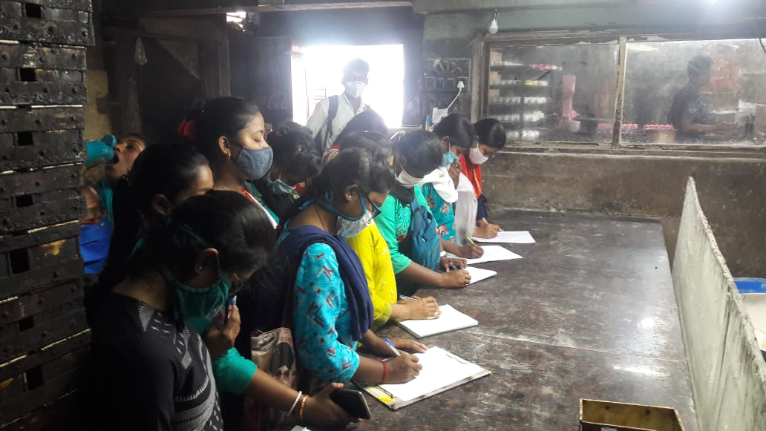
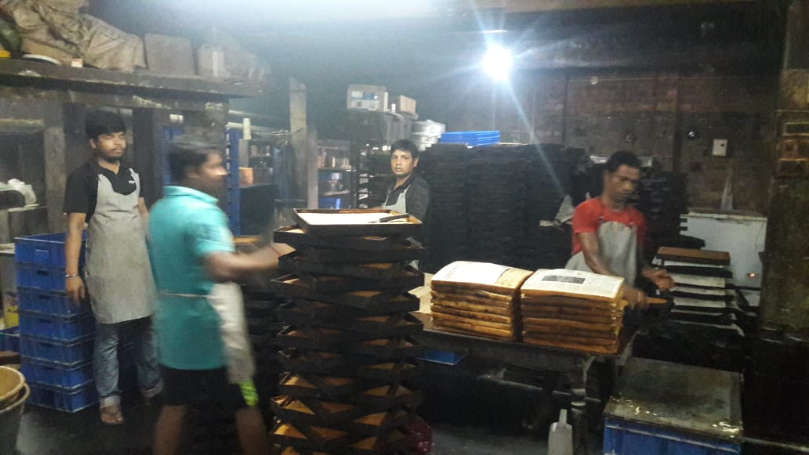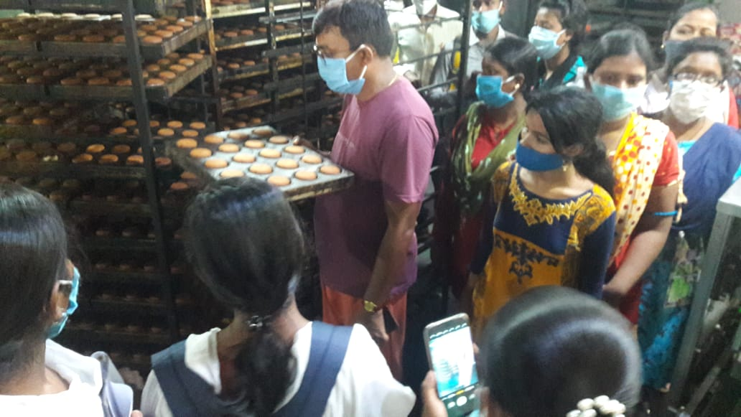
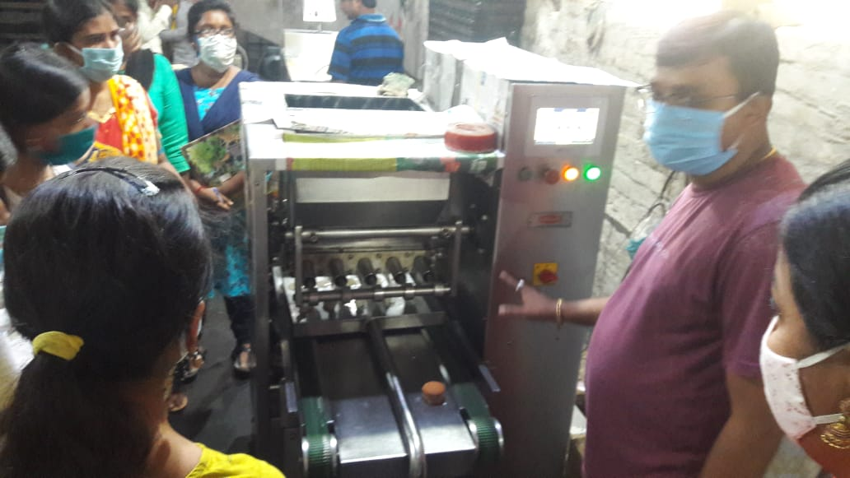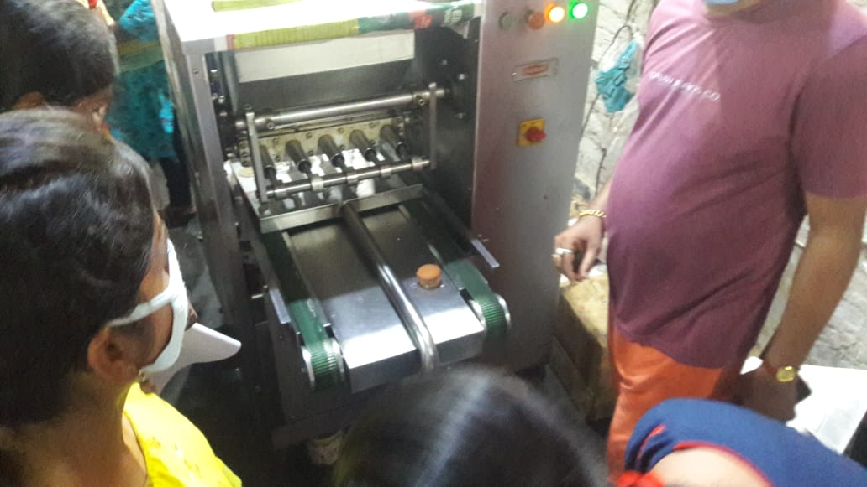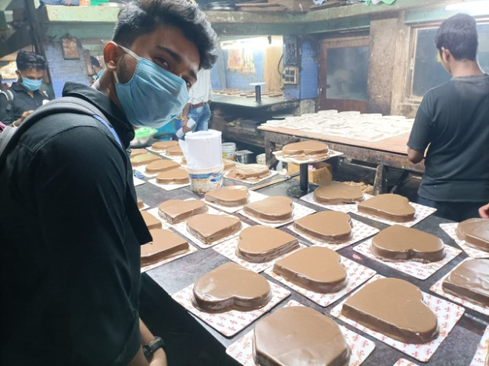

ATTANDANCE OF STUDENTS:

- Souman Das
- Ayan Mondal
- Urmila Bag
- Saikat Mondal
- Srikrishna Jana
- Sudeshna Maity
- Supriya Mahi
- Susmita Kamila
- Siuli Kar
- Sonali Patra
- Barnali Barik
- Sutopa Paria
- Pratima das
- Soma manna
- Kadernath maity
- Joysri jana
- Sathi das
- Arpita kamila
- Ajoy roy
- Arka mukherjee
- Dipanwita maity
- Indrajit dolai
- Perona maity
- Rakhi maity
- Sathi chatterjee
- Sheuli day
- Shreyasri roy chowdhury
- Tanusree jana
- Sourav jana
- Sambhu day
- Yeamin Ali
- Kousic bera
- Tapan manna

RESOLUSION:
- The art of baking remains a fundamental skill and is important for nutrition as baked goods, especially breads, are a common and important food from an economic and cultural point of view.
- A person who prepares baked goods as a profession is called a baker.
- Bakery food safety programs minimize the risk of bacterial, physical, and chemical contaminants in the final bakery products.

